Water Jug Problem:
AIM:
To write a Python program to solve the Water Jug Problem using state-space search.

ALGORITHMS:
1. Start.
2. Initialize two jugs with capacities \(x\) and \(y\).
3. Set both jugs to empty.
4. Apply fill, empty, or pour operations.
5. Check whether the target amount is reached.
6. If reached, display the solution.
7. Otherwise, repeat the operations.
8. Stop.

CODE:
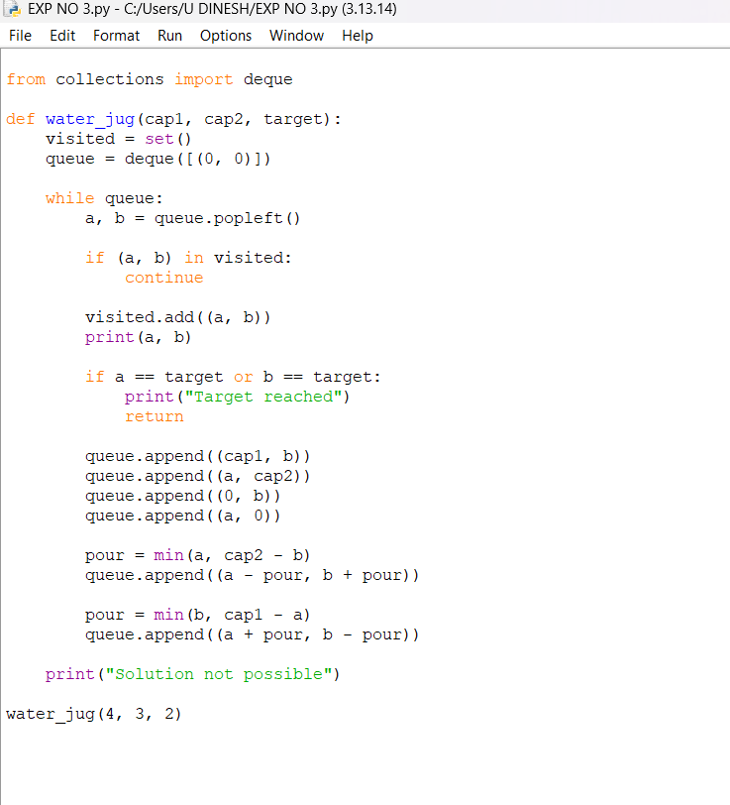

OUTPUT:
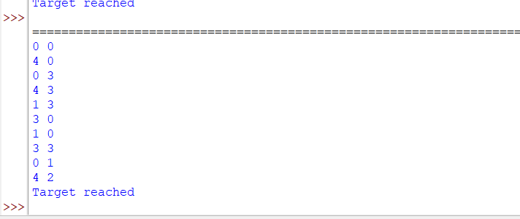

RESULT:
Water Jug Problem: The required amount of water is obtained using the given water jugs.

